Applicable Objects/适用对象
Site/厂区 | TJ1 TJ2 TJ3 TJ4 FX1 FX2 DH1 DH2 DH3
Department/部门 | Production Department, Quality Assurance Department  生产部，质量保证部

Equipment Function/设备功能介绍
This equipment uses water for injection (WFI) as the humidification medium to humidify nitrogen. Nitrogen fed into the equipment is brought into full contact with WFI and is humidified, delivering humidified nitrogen at a stable humidity.
本设备以注射用水作为加湿介质，用于对氮气进行加湿处理。氮气通入设备内与注射用水充分接触，实现增湿，输出湿度稳定的湿氮气。

Equipment Structure/设备结构介绍
The nitrogen humidifier mainly consists of a bubbler tank, transfer pump, filters, vent filter, control valve, pressure sensor, temperature sensor, transfer lines and valves.
氮气加湿器主要由鼓泡罐、输液泵、过滤器、呼吸器、调节阀、压力传感器、温度传感器，转移管路、阀门等部分组成。
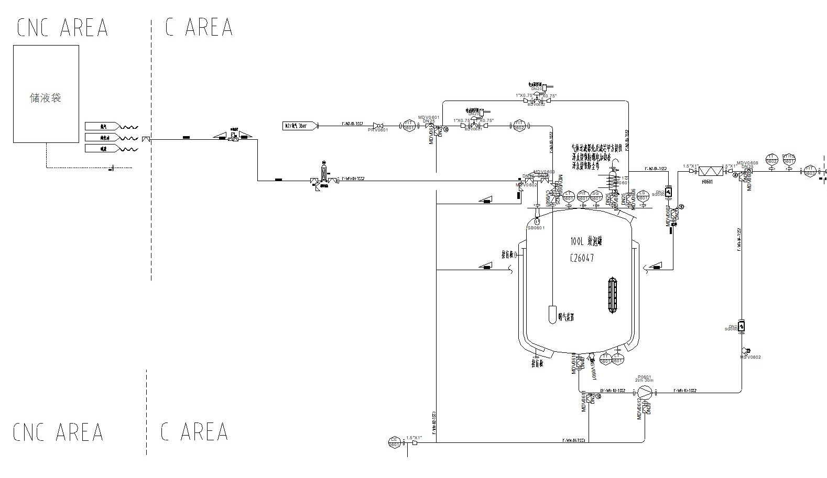

Operating Procedure/设备操作流程

Collecting WFI with a Storage Bag and Transfer Drum/使用储液袋和转移桶取用注射用水的操作方法
    - Transfer Drum Structure/转移桶结构
The transfer drum consists of a lid, a drum body and a stainless steel transport dolly. The drum body is graduated to show operators the volume of WFI in the storage bag. An outlet at the lower side of the drum is used to route the drain line of the storage bag. See Figure 4.1.1 and Table 4.1.1.
转移桶由桶盖、桶身、不锈钢转运底座组成。桶身标有刻度，用于提示人员储液袋内注射用水的体积。桶下配有侧底部出液口，用于放置储液袋的放液管路。示意图见图4.1.1，表4.1.1。
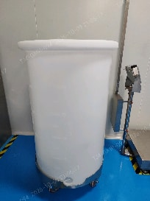
①
②
③
④
Figure 4.1.1 Transfer Drum Structure
图4.1.1 转移桶结构图
Table 4.1.1 Transfer Drum Parts List
表4.1.1 转移桶部件清单
No./序号 | Name/名称
① | Lid  桶盖
② | Drum body  桶身
③ | Stainless steel transport dolly  不锈钢转运底座
④ | Lower side outlet  侧底部出液口
    - Storage Bag Structure/储液袋结构
The storage bag mainly consists of the bag body, fill line, drain line and sampling line. See Figure 4.1.2 and Table 4.1.2.
储液袋主要由袋身、进液管路、放液管路、取样管路组成。示意图见图4.1.2，表4.1.2。
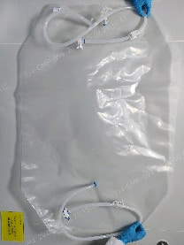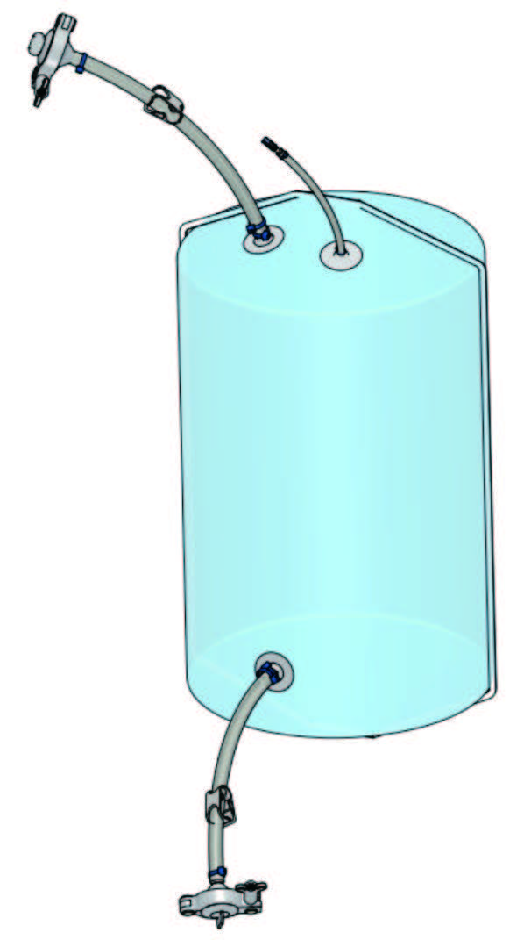
②

④
③
①
⑤
Figure 4.1.2 Storage Bag Structure
图4.1.2 储液袋结构图
Table 4.1.2 Storage Bag Parts List
表4.1.2 储液袋部件清单
No./序号 | Name/名称
① | Bag body  袋身
② | Fill line  进液管路
③ | Drain line  放液管路
④ | Sampling line  取样管路
⑤ | Pinch clamp  止液夹
Each line is fitted with a pinch clamp, which opens and closes the storage bag tubing and regulates the flow. Push the latch back to release the tubing and open the line; slide the clamp body to fine-tune the flow rate; push it to the front end to compress the tubing and close the line, isolating the fluid. See Figure 4.1.3.
每条管路上都配有一个止液夹，止液夹用于储液袋软管的通断与流量调节。向后拨卡扣松开软管，管路导通；滑动夹体可微调流速；推至前端压紧软管，即可关断管路，实现流体隔离。示意图见图4.1.3。
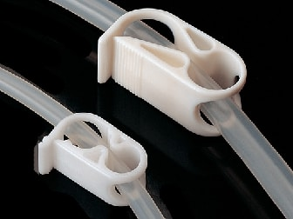
Figure 4.1.3 Pinch Clamp Structure
图4.1.3 止液夹结构图
The fill line has a sanitary quick-release closure, mainly consisting of an end cap, a sealing O-ring and a Tri-clamp. Make sure this connection is properly sealed before use and after WFI collection. See Figure 4.1.4 and Table 4.1.3 for the diagram and components.
进液管路配有快开密封，主要由堵头、密封O型圈、快开卡子组成，使用前和接水结束后需要确保该接口密封完好。示意图及结构介绍见图4.1.4，表4.1.3。
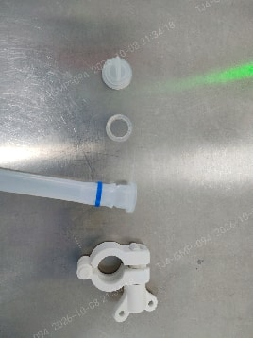
①
②
③
④
Figure 4.1.4 Fill Line Connector Structure
图4.1.4 进液管路接头结构图
Table 4.1.3 Fill Line Connector Parts List
表4.1.3 进液管路接头部件清单
No./序号 | Name/名称
① | Sealing end cap  密封堵头
② | Sealing O-ring  密封O型圈
③ | Fill line  进液管路
④ | Tri-clamp  快开卡子
The drain line is fitted with an aseptic connector for closed, aseptic connection between single-use storage bag lines, enabling aseptic transfer of WFI and other liquids. The connector is single-use; once connected, it cannot be disconnected and reconnected.
放液管路配有无菌连接接口，用于一次性储液袋管路之间的密闭无菌对接，实现注射用水等液体的无菌转移，该接头为一次性使用，连接后不可重复拆装。
The connector mainly consists of protective pull tabs, a sterile barrier membrane, a snap-lock housing, a hose barb and a sealing O-ring. See Figure 4.1.5 and Table 4.1.4.
该接头主要由保护拉片、无菌隔离膜、外壳卡扣锁止机构、软管插接端、密封O型圈组成。示意图见图4.1.5，表4.1.4。
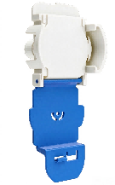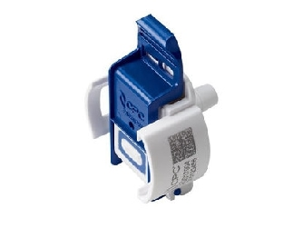
①
③
④
⑤
②
Figure 4.1.5 Aseptic Connector Structure
图4.1.5 无菌连接接头结构图
Table 4.1.4 Aseptic Connector Parts List
表4.1.4 无菌连接接头部件清单
No./序号 | Name/名称
① | Protective pull tab  保护拉片
② | Sterile barrier membrane  无菌隔离膜
③ | Snap-lock housing  外壳卡扣锁止机构
④ | Hose barb  软管插接端
⑤ | Sealing O-ring (internal)  密封O型圈（内部）
    - Preparation/操作前准备
Before transferring WFI with the storage bag and transfer drum, confirm that the following items are ready: transfer drum, storage bag, dedicated WFI hose, Tri-clamps, gaskets, etc.
使用储液袋和转移桶进行注射用水的转移前，需确认如下器具已准备完全：转移桶、储液袋、注射用水专用软管、快开卡子、垫片等。
    - Pre-operation Checks/操作前检查
No./序号 | Check Item/检查内容
① | Check that the status label at the WFI point of use shows “Qualified – Released for Use” and that the WFI temperature sensor is within its calibration period  检查注射用水使用点状态标识处于“合格准用”状态，注射用水温度传感器在校验有效期内  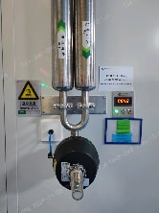  WFI point-of-use status label  注射用水使用点状态标识  Temp. sensor calibration label  温度传感器校验标识
② | Check that the dedicated WFI hose is within its expiry date and is intact and clean, with no damage, foreign matter or other abnormalities  检查注射用水专用软管在有效期内，软管完好洁净，无破损、无外来异物等异常情况  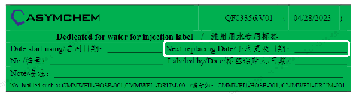
③ | Check that the storage bag body, lines and all other components are intact and clean, with no damage, foreign matter or other abnormalities  检查储液袋袋身、管路等所有配件完好洁净，无破损、无外来异物等异常情况
④ | Check that the pinch clamps on all storage bag lines are fully closed, compressing the tubing  检查储液袋各管路上的止液夹均处于压紧隔断状态
⑤ | Check that the protective cover of the aseptic connector on the storage bag drain line is intact and undamaged  检查储液袋放液管路无菌连接器保护盖完好，无破损
    - Collecting WFI/取用注射用水
No./序号 | Operation/操作描述
① | Connect one end of the dedicated WFI hose to the WFI point of use  将注射用水专用软管一端连接到注射用水使用点上  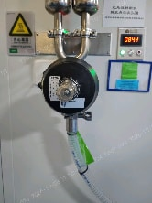
② | Press the “Start” button on the WFI panel and wait for the WFI to cool to ambient temperature; water is then dispensed automatically.  按下注射用水面板上的“启动”按钮，等待注射用水温度降至常温后自动出水。  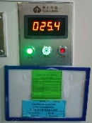
③ | Once WFI starts flowing, let it run for at least 1 minute to thoroughly flush the inner wall of the dedicated WFI hose (if a reducer is needed for the connection, flush it together with the hose)  注射用水出水后，持续放水至少1分钟，充分冲洗注射用水专用软管内壁（如需变径连接，则需要同变径一起冲洗）
④ | Lay the storage bag flat inside the transfer drum and route its drain line out through the lower side outlet (the line and connector must not touch the floor)  将储液袋平整放入转移桶内，将储液袋放液管路从侧底部出液口拿出（管路和接头不可接触地面）  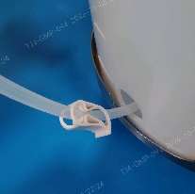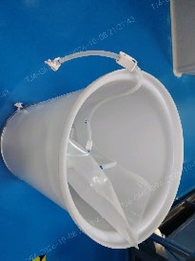
⑤ | After flushing, connect the other end of the dedicated WFI hose to the fill line connection of the storage bag  冲洗结束后，将注射用水专用软管另一端连接至储液袋进液管接口  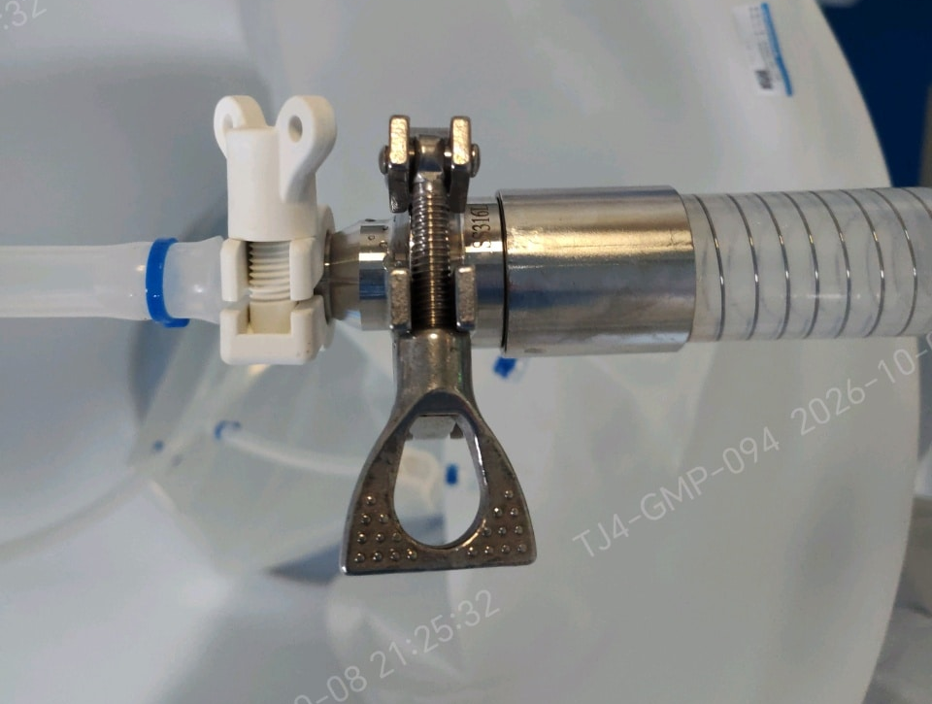
⑥ | Open the pinch clamp on the storage bag fill line, then open the WFI point-of-use valve to collect WFI  打开储液袋进液管路止液阀，打开注射用水使用点阀门，从注射用水使用点取用注射用水
⑦ | When the required volume is reached, close the WFI point-of-use valve and then the pinch clamp on the storage bag fill line. Disconnect the dedicated WFI hose from the fill line and seal the fill line with the end cap. Disconnect the dedicated WFI hose from the point of use, drain and dry it, then hang it for storage  达到所需体积后依次关闭注射用水使用点阀门、储液袋进液管路止液阀，断开注射用水专用软管与储液袋进液管，将储液袋进液管路使用堵头密封。断开注射用水专用软管与注射用水使用点连接，排净干燥后悬挂存放  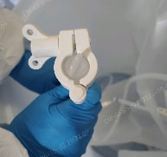
⑧ | Lay the fill line flat inside the drum, close the transfer drum lid and hold for use  将进液管路平整放入桶内，盖上转移桶盖，等待使用
    - Connecting the Storage Bag to the Nitrogen Humidifier/将储液袋连接至氮气加湿器
    - Using the Aseptic Connector/无菌连接接头使用方法
No./序号 | Operation/操作描述
① | Open the blue protective pull-tab covers on both connector halves and fold them down  掰开两侧连接器半体上的蓝色保护拉片盖，向下翻折
② | Align the two connector halves with the pull-tab covers facing down. Push the halves together in the direction of the arrows  对齐连接器两半体，保持拉片盖朝下。按照箭头指示，将两个半体对推合拢  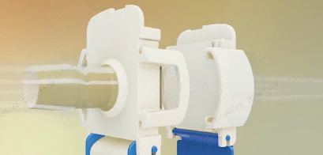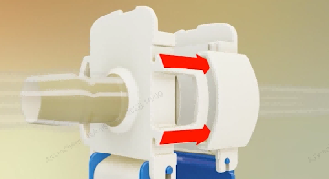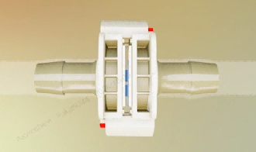
③ | Squeeze both sides of the connector until the latch clicks, confirming a secure connection. Visually check that both end faces are flush and parallel  分别挤压连接器两侧，直至听到卡扣“咔哒”声，确认形成牢固连接。目视检查两侧端面齐平、相互平行  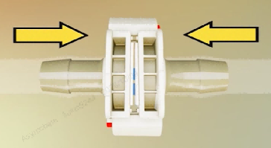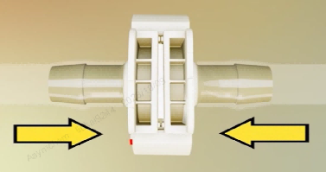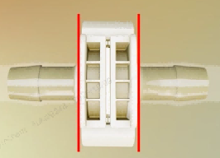
④ | Press the blue pull tabs to close the pull-tab covers  按压蓝色拉片，将拉片盖合上  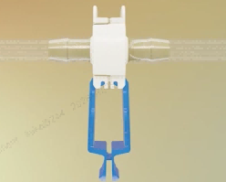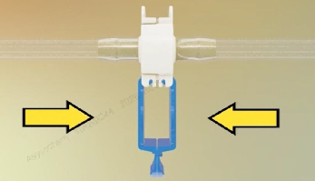  Pull the blue pull tab to peel the sterile barrier membrane out of the connector  拉动蓝色拉片，从连接器上撕下无菌隔离膜  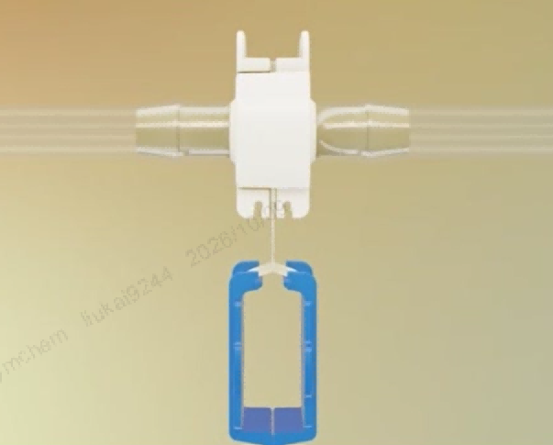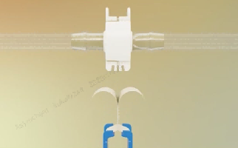
⑤ | The connection is complete and liquid transfer can begin  连接完毕，可以进行液体输送  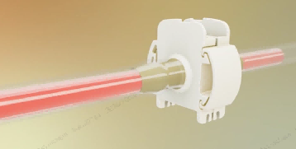

Collecting WFI with a Stainless Steel Water Drum/使用不锈钢水桶取用注射用水的操作方法
    - Stainless Steel Water Drum Structure/不锈钢水桶结构
The stainless steel water drum consists of a drum body and a stainless steel transport dolly. The top of the drum has a water inlet, a gas port and a sight glass port, and the bottom has a water outlet. All valves on the drum are diaphragm valves. See Figure 4.2.1 and Table 4.2.1.
不锈钢水桶由桶身、不锈钢转运底座组成。桶上设计有一个进水接口、一个气体接口、一个视镜口，桶下设计一个放水接口，桶上阀门均为隔膜阀。示意图见图4.2.1，表4.2.1。
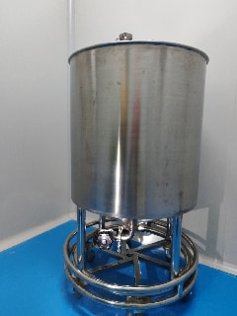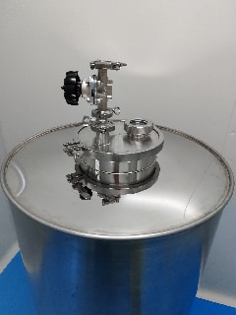
⑦
⑥
①
②
③
④
⑤
⑦
Figure 4.2.1 Stainless Steel Water Drum Structure
图4.2.1 不锈钢水桶结构图
Table 4.2.1 Stainless Steel Water Drum Parts List
表4.2.1 不锈钢水桶部件清单
No./序号 | Name/名称
① | Drum body  桶身
② | Stainless steel transport dolly  不锈钢转运底座
③ | Water inlet  进水口
④ | Gas port  气体接口
⑤ | Sight glass port  视镜接口
⑥ | Water outlet  放水口
⑦ | Diaphragm valve  隔膜阀
    - Preparation/操作前准备
Before transferring WFI with the stainless steel water drum, confirm that the following items are ready: dedicated stainless steel WFI drum, dedicated WFI hose, Tri-clamps, gaskets, pressure gauge, filter, etc.
使用不锈钢水桶进行注射用水的转移前，需确认如下器具已准备完全：注射用水专用不锈钢水桶、注射用水专用软管、快开卡子、垫片、压力表、过滤器等。
Install the filter and pressure gauge on the stainless steel water drum. See Figure 4.2.2 and Table 4.2.2 for the installation diagram.
将过滤器、压力表安装在不锈钢水桶上，安装示意图见图4.2.2，表4.2.2。
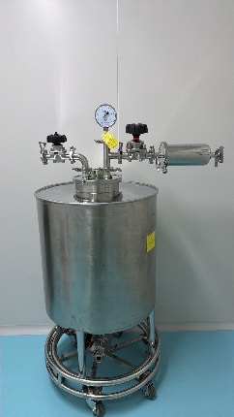
①
②
③
④
⑤
⑥
⑥
⑥
⑦
⑧
⑨
Figure 4.2.2 Installation Diagram
图4.2.2 安装示意图
Table 4.2.2 Parts List after Installation
表4.2.2 安装后部件清单
No./序号 | Name/名称
① | Pressure gauge  压力表
② | Filter  过滤器
③ | Water inlet  进水口
④ | Water outlet  放水口
⑤ | Sight glass port  视镜接口
⑥ | Diaphragm valve  隔膜阀
⑦ | Gas port  气体接口
⑧ | Drum body  桶身
⑨ | Stainless steel transport dolly  不锈钢转运底座

    - Preparation/操作前准备

